**MSME IDEA HACKATHON 4.0**

**K.RAMAKRISHNAN COLLEGE OF TECHNOLOGY**

**NAME: M.GAJAMOULI**

**PHONE NUMBER : 8015417969**

1. **Title of proposed idea/innovation:**

|  |
| --- |
| **TO MAKE PENCILE FROM DRY LEAVES** |

1. **Briefly explain newness/uniqueness of the innovation**

|  |
| --- |
| Making pencils from dried leaves is a novel idea because it is a sustainable and environmentally beneficial method. While conventional pencils use wood, which contributes to deforestation, this invention turns natural waste dry leaves into useful goods. By using renewable and biodegradable resources, this approach lessens its impact on the environment and may even result in lower production costs. The idea of recycling waste into a functional product gives value to resources that would otherwise be thrown away, providing a creative solution that encourages sustainability in the pencil manufacturing sector. |

1. **Concept & Objective**

|  |
| --- |
| **Concept:** The concept is to make a pencil out of dry leaves or other recyclable or environmentally friendly materials. This strategy supports environmental initiatives by using less wood and recycling natural waste.  **Objective:**  **Goal Sustainability:** Reduce environmental effect through use of biodegradable materials.    **Innovation:** Investigating natural substitutes for commonplace items like pencils.  **garbage Reduction:** recycling dehydrated leaves to create a useful product out of garbage.  To create an environmentally friendly writing instrument, dry leaves would be bound or compacted into a strong structure that can encapsulate a graphite core. |

1. **Specify the potential areas of application in industry/market in brief.**

|  |
| --- |
| Dry leaf pencils can attract environmentally conscious consumers and promote sustainable, biodegradable goods for use in business, education, and the arts. |

1. **Briefly provide the market potential of idea/innovation.**

|  |
| --- |
| Pencils manufactured from dried leaves have a huge commercial potential and fit in with eco-friendly tendencies. It appeals to educational institutions and ecologically aware consumers by providing a sustainable substitute for pencils made of wood. |

1. **Block diagram / Flow chart**

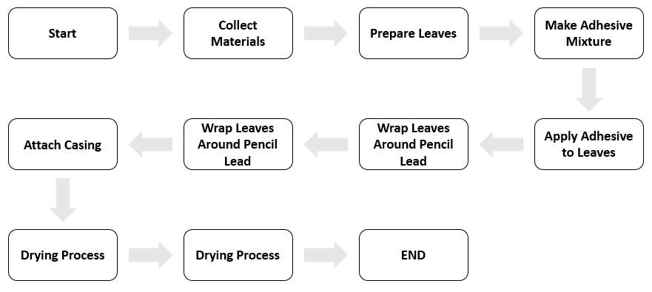

**7. Related Diagram**